High Performance Computing Platforms Step7. Stochastic Computing

IS/BS/MS

No.

Name

**●Fill the blanks in the following table to describe the shown bit-stream in stochastic values. Pick two stochastic numbers in this example and feed them into AND gate, verify the multiply result.**

|  |  |  |  |  |
| --- | --- | --- | --- | --- |
| **Bit-stream** | **UP** | **BP** | **IBP** | **Ratio** |
| 00000000 | 0 | -1 | +1 | 0 |
| 00000001 | 1/8 | -3/4 | +3/4 | 1/7 |
| 00000011 | 2/8 | -2/4 | +2/4 | 1/3 |
| 00000111 |  |  |  |  |
| 00001111 |  |  |  |  |
| 00011111 |  |  |  |  |
| 00111111 |  |  |  |  |
| 01111111 |  |  |  |  |
| 11111111 |  |  |  |  |

**●Derivate the function by following circuits.**

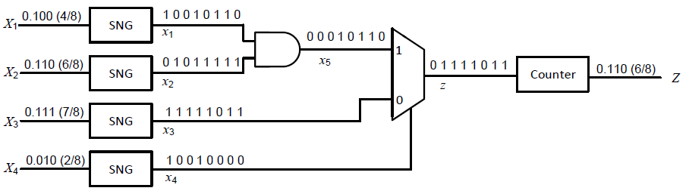

**●Derivate the function of OR gate. Hint: Z = X + Y - XY**

